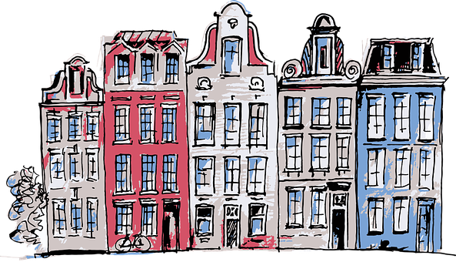

|  |  |  |  |  |
| --- | --- | --- | --- | --- |
| **”Big words”** | **”Sweet words”** | **Building words** | **Technical words** | **”Hideous words”** |
|  |  |  |  |  |